**The Battle of the Neighbourhoods**

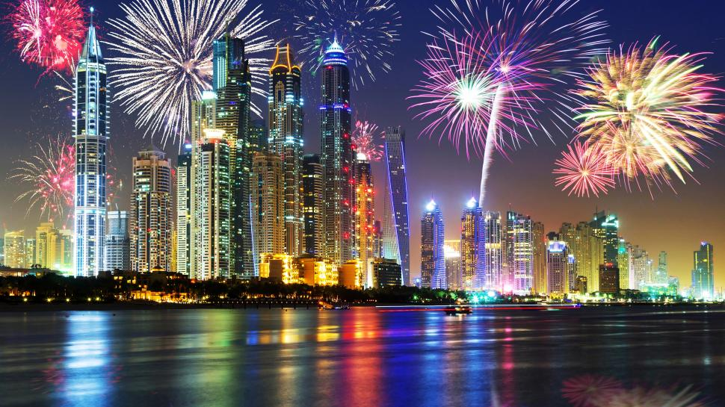

Image Curtsey: https://encrypted-tbn0.gstatic.com/images?

**Introduction:**

A friend of mine who wants to start a new business in food and beverage wishes to evaluate the available opportunities and would like it to be a profitable venture by using digital tools available today. **To choose between a food joint, restaurant or café and which place will be the most profitable or happening for him.**

UAE is a country which has a significant number of expats who come from almost 200 different countries of the world. It is cosmopolitan country which accommodates multicultural communities. Which provides ample business opportunities and friendly business environment.

It always been an attraction for different business players into the market, being a global hub of opportunities for business and commerce in the field of banking and finance, retailing, world trade, transportation, tourism, real estate, new media, traditional media, advertising, legal services, accountancy, insurance, theatre, fashion, and the arts in the United Arab Emirates. However, the market is highly competitive due to its highly developed cities and better infrastructure so cost of doing business is also on the higher side.

Thus, any new business venture or expansion needs to be carefully planned and analysed. The insights derived from analysis will give good understanding of the business environment which help in strategically targeting the market. This will help in reduction of risk. And the Return on Investment will be reasonable.

**Business Problem:**

1. Which is the most suitable place among Seven Emirates?
2. Which is the most suitable city?
3. What is the most common choice food joint, café or restaurant?

**Background**

UAE a restaurant business which prepares and serves food and drink to customers can be quite competitive and versatile to fulfil customers food choices. The Cities of UAE is famous for its excellent cuisine diversity to cater for different nationalities. Its food culture includes an array of international cuisines influenced by the expat population amounting to approximately 88 to 89 % of total population. in the cities of Seven Emirates.

Hence it is evident that to survive such competition, it is very important to strategically plan. Various factors need to be studied in order **to choose between a food joint, restaurant or café**:

Choice of the correct location to start its first venture can lead to expansion, brand development and franchise in future. First move is to choose which one and where?

**Target Audience:**

To recommend the business and its preferred location, is the task given to me. However, this can be targeted towards any such propositions in any field or business type with a little refinement.

The objective is to recommend between the given choices & than choose a neighbourhood location which will be best choice to start a food joint, restaurant or a cafe. It should meet the expectations to justify the rationale of the recommendations made. This would interest anyone who wants to start a new food joint, Café, or a restaurant in UAE.

**Criteria for success:**

The criteria of success of the project will be a good recommendation of borough/Neighbourhood choice to my friend based on data driven result.

**Use of data:**

1. Population data is downloaded from www.globalmediainsight.com (refer link below) gives population statistics of various nationalities (Expat) in UAE and used to understand the type of target customers and their choice and preferences.

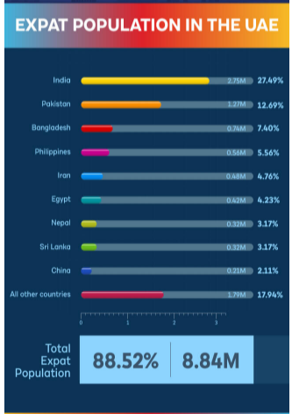 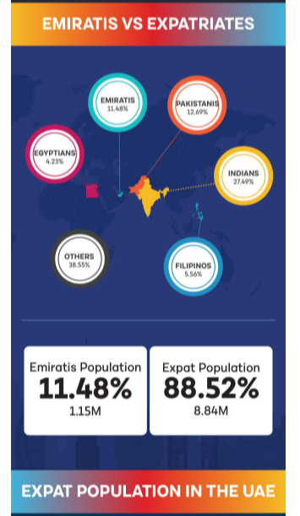

1. Cities data is downloaded from <https://en.wikipedia.org> consists of 4 fields “city, latitude, longitude and Emirates” it is in used to select which city can be a better choice.

1. Foursquare neighbourhood data is used to analyse neighbourhood cities, categories of businesses in neighbourhood, to understand density and competition in neighbouring locations, to select a better choice for business and city and where in city.

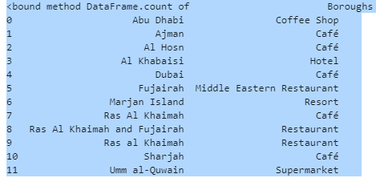

**Methodology**

1. The Initial step was to understand type of customers and their preferences and choices. The next was to check on places and neighbourhoods was used to analyse neighbourhood cities, segmenting and clustering is performed using K-means to compare & select a better choice for business and city and where in city. To identify
2. Topmost common venues to identify most suitable business type among Food joint, café or restaurant.
3. Their proximity to popular visiting /travel attractions for expats / travellers.
4. Choose among Seven Emirates and then for a city in the selected Emirates.

**Results cum Discussion:**

1. The choice of **most suitable** place among Seven Emirates is very clear (refer output below) So the top three Emirates were found to be **Abu Dhabi, Dubai and Ras Al Khaimah**.

1. The **top choice** of city among these resulted to be **Dubai** which has more visitor ratio compared to Abu Dhabi and Ras Al Khaimah. Further in Dubai near **Burj Khalifa.**
2. The last and final choice **food joint, café or restaurant,** this also is very clear from **Topmost** common venues result **as Café / Coffee Shop.**

**Conclusion**

**The analysis identifies and answers all the questions**

1. Which is the most suitable place among Seven Emirates? - **Dubai**
2. Which is the most suitable city? - **Dubai near** **Burj Khalifa**
3. What is the most common choice food joint, café or restaurant? - **Café / Coffee Shop**

**Description of the data sources (& citation):**

1. <https://www.globalmediainsight.com/blog/uae-population-statistics/> images and data of Expat population in UAE
2. <https://en.wikipedia.org/wiki/List_of_cities_in_the_United_Arab_Emirates> for data on Cities of UAE and their coordinates. (However minor additions using google.com for coordinates of few cities were also used).
3. <https://api.foursquare.com/v2/venues/explore> to find the neighbourhood of such locations
4. <https://stackoverflow.com/questions> for code corrections
5. <https://www.google.com/> for all data related queries which came during the project.
6. <https://encrypted-tbn0.gstatic.com/images>? For main image